SMARTEDA

A Project Report Submitted in the partial fulfillment of the requirements for the award of the degree of

BACHELOR OF TECHNOLOGY
In

DEPARTMENT OF CSE
By
Student Name | :K Sai Vignesh
Student Name | :A.Sai Shrawan
Student Name | :Shaik Aman

Under the Esteemed Guidance of

B.Prathusha

Assistant Professor

Department of CSE

AY-2026-2027

Semester:3-1




K L (Deemed to be) University DEPARTMENT OF CSE

Declaration

The Project Report entitled “Smart EDA” is a record of Bonafide work of K.SaiVignesh – 2420030007, A.SaiShrawan – 2420030268,Shaik Aman – 2420030183 submitted in partial fulfillment for the award of B. Tech in CSE to the K L University. The results embodied in this report have not been copied from any other departments/University/Institute.

K.Sai Vignesh – 2420030007
A.Sai Shrawan – 2420030268
Shaik Aman – 2420030183

K L (Deemed to be) University DEPARTMENT OF CSE

CERTIFICATE

This is certify that the mini project based report entitled “Smart EDA” is a bonafide work done and submitted by K.SaiVignesh – 2420030007, A.SaiShrawan – 2420030268,Shaik Aman – 2420030183 in partial fulfillment of the requirements for the award of the degree of BACHELOR OF TECHNOLOGY in Department of CSE K L (Deemed to be University), during the academic year 2026-2027.

Signature of the Guide

Signature of the Course Coordinator Signature of the HOD

ACKNOWLEDGEMENT
The success in this project would not have been possible but for the timely help and guidance rendered by many people. Our wish to express my sincere thanks to all those who has assisted us in one way or the other for the completion of my project.

Our greatest appreciation to my Course Coordinator, and my guide B.Prathusha, Department of CSE which cannot be expressed in words for his/her tremendous support, encouragement and guidance for this project.

We express our gratitude to Dr. P.Venkateshwar Sir (CSE), Head of the Department for CSE for providing us with adequate facilities, ways and means by which we are able to complete this project-based Lab.

We thank all the members of teaching and non-teaching staff members, and also who have assisted me directly or indirectly for successful completion of this project. Finally, I sincerely thank my parents, friends and classmates for their kind help and cooperation during my work.

K.Sai Vignesh – 2420030007
A.Sai Shrawan – 2420030268
Shaik Aman – 2420030183

Abstract
SmartEDA is a Python-based interactive exploratory data analysis application designed to identify and examine subgroup pattern reversals, including patterns associated with Simpson's paradox. A reversal can occur when the relationship between two numeric variables in the combined dataset differs in direction from the relationship observed within individual groups. Such reversals can lead to misleading conclusions when subgroup structure is ignored.The application accepts a user-uploaded CSV file and allows analysis of two numeric variables and a categorical grouping variable. Its processing pipeline calculates Pearson correlation coefficients and p-values for the complete dataset and for each subgroup, identifies opposite-sign correlations, checks minimum sample-size requirements, applies Benjamini–Hochberg correction to subgroup p-values, and estimates reversal stability through stratified bootstrap resampling. A Dash interface with Plotly visualizations and tabular outputs makes the analysis accessible through a browser.The supplied project includes synthetic datasets for a known reversal and for consistent trends, automated tests, and saved evaluation reports. In the recorded evaluation, the detector achieved an accuracy of 1.00 on each of three synthetic test scenarios: a known reversal, consistent trends, and a reversal dataset with 5% missing outcome values. In the known-reversal stability experiment, both groups had a reported reversal stability rate of 1.00 across 200 bootstrap iterations. These are results on controlled synthetic data and should not be interpreted as evidence of equivalent performance on all real-world datasets.

Index
S. No. | Chapters | Topics | Page.no
 |  | Acknowledgement
 |  | Abstract
1 | Introduction | 1.1 Background of the project  1.2 Problem statement  1.3 Scope of the project  1.4 Objective(s)  1.5 Importance of the application  1.6 Target users/audience | 1-10
2 | System Requirements | 2.1 Hardware requirements  2.2 Software requirements  2.3 Development tools and frameworks | 11-20
3 | Technology Stack | 3.1 Front-end (e.g., React.js, Angular, HTML/CSS)  3.2 Back-end (e.g., Node.js, Django, Spring Boot)  3.3 Database (e.g., MongoDB, MySQL, PostgreSQL)  3.4 Version Control (e.g., Git, GitHub)  3.5 APIs or External services (e.g., Firebase, Stripe) | 21-30
4 | System Architecture | 4.1 High-level architecture diagram  4.2 Description of each layer (frontend, backend, database)  4.3 Deployment architecture (e.g., cloud, local, CI/CD pipelines) | 31-35
5 | Design | 5.1 Wireframes or mockups  5.2 ER Diagram / Database schema | 36-42
6 | Implementation | 6.1 Module-wise implementation  6.2 Front-end logic (UI rendering, state management)  6.3 Backend logic (routes, controllers, business logic)  6.4 Database connectivity  6.5 API integration  6.6 Authentication & Authorization | 43-55
7 | Features | 7.1 List of main features  7.2 How each feature works (user perspective + technical description) | 56-60
8 | Testing | 8.1 Postman testing (frontend/backend)  8.2 Integration testing  8.3 Tools used for testing  8.4 Test cases and results | 61-67
9 | Deployment | 9.1 Steps to deploy  9.2 Environment configuration  9.3 Hosting of frontend and backend | 68-73
10 | Challenges & Limitations | 10.1 Issues faced during development  10.2 Solutions applied  10.3 Current limitations or known bugs | 74-80
11 | Future Enhancements | 11.1 Planned features  11.2 Possible integrations or optimizations | 81-88
12 | Conclusion | 12.1 Summary of the project  12.2 What was achieved  12.3 Skills learned during development | 89-100
13 | References | - Books, tutorials, APIs, documentation sites used
14 | Appendices | - Screenshots of the app  - Sample code snippets  - Installation/setup instructions  - User manual or guide  -certifications

CHAPTER 1
Introduction

1.1 Background of the Project
Exploratory Data Analysis (EDA) is an important step in understanding datasets before building predictive models or drawing conclusions. It helps analysts examine data distributions, identify missing values, discover relationships between variables, and understand differences among groups.A relationship observed in a complete dataset may not always match the relationships present within its subgroups. One important example is Simpson's paradox, where an association observed in aggregated data differs in direction from the associations observed within individual groups.SmartEDA focuses on this analytical problem. It compares the Pearson correlation between two numeric variables in the overall dataset with the correlations calculated separately for each category of a grouping variable. The application helps users identify potential pattern reversals and examine whether the evidence is statistically supported and stable under resampling.By combining statistical calculations with an interactive dashboard, SmartEDA aims to make subgroup analysis easier to perform and understand. It provides an organized workflow for examining aggregate and subgroup relationships without requiring users to manually calculate every correlation.

1.2 Problem Statement
Analysts may draw incomplete or misleading conclusions when they examine only the overall relationship between two variables and ignore meaningful subgroups within the dataset.For example, two variables may have a positive correlation in the combined dataset while showing negative correlations within individual groups. This difference may occur because the groups have different distributions or compositions.Manually checking every subgroup can be time-consuming. In addition, performing statistical tests across multiple groups without correcting for multiple comparisons can increase the risk of false-positive findings.Therefore, there is a need for a repeatable analytical application that compares overall and subgroup relationships, detects potential sign reversals, reports relevant statistical evidence, accounts for multiple comparisons, and provides an indication of how consistently the pattern appears under resampling.SmartEDA addresses this problem through an interactive Python-based application that integrates correlation analysis, subgroup validation, bootstrap stability estimation, and result visualization.

1.3 Scope of the Project
The scope of SmartEDA includes the following functions:
- Accepting CSV files through a browser-based dashboard.
- Identifying numeric columns that can be used for correlation analysis.
- Allowing a categorical column to define subgroups.
- Calculating Pearson correlation coefficients and associated p-values for the complete dataset.
- Calculating correlations separately for individual groups.
- Identifying subgroup correlations whose signs differ from the overall correlation.
- Applying minimum sample-size and statistical significance checks.
- Applying Benjamini–Hochberg false-discovery-rate correction to subgroup p-values.
- Estimating reversal stability using stratified bootstrap resampling.
- Displaying results in tables and interactive visualizations.
- Evaluating the analysis pipeline using controlled synthetic datasets.
- Saving detection and evaluation results in CSV format through the corresponding project scripts.
The current implementation is primarily a statistical analysis prototype. It does not establish causality, automatically identify every scientifically relevant confounding variable, or guarantee that every detected reversal is meaningful in every application domain.

1.4 Objectives
The main objective of SmartEDA is to develop an interactive tool for investigating subgroup pattern reversals in structured datasets.
The specific objectives are:
- To build a user-friendly dashboard for uploading and analysing CSV data.
- To compare the correlation between two variables in the overall dataset with their correlations within individual groups.
- To identify potential sign reversals that may be overlooked by aggregate analysis.
- To provide statistical validation using sample-size requirements and significance checks.
- To reduce avoidable false-positive interpretations through multiple-testing correction.
- To estimate the stability of reversal patterns using bootstrap resampling.
- To display statistical results in a form that is easier to interpret.
- To evaluate the system using synthetic datasets representing known reversals, consistent trends, and missing-value conditions.
- To support reproducible analysis through modular code and automated tests.

1.5 Importance of the Application
SmartEDA is useful because aggregate statistics do not always provide a complete picture of relationships within data. When a dataset contains multiple groups, the overall relationship between variables may differ from the relationship observed inside each group.
The application helps users identify such differences and investigate whether the overall trend adequately represents the underlying subgroups.
The tool can support data analysis in areas such as educational outcomes, operational measurements, customer segmentation, and other domains where data naturally contains categories or groups.
Its interactive interface reduces the need for repetitive manual calculations. Its statistical validation and bootstrap analysis provide additional information that helps users evaluate whether a detected reversal is supported by the available data.
However, SmartEDA should be used as an exploratory aid rather than an automatic decision-making system. Results should be interpreted with domain knowledge, appropriate assumptions, and awareness of the limitations of correlation analysis.

1.6 Target Users / Audience
The intended users of SmartEDA include:
- Students: Students learning statistics, correlation analysis, and exploratory data analysis.
- Researchers: Researchers investigating relationships within grouped datasets.
- Data analysts: Analysts who need a repeatable first-pass screening tool for potential subgroup reversals.
- Educators: Teachers and instructors demonstrating Simpson's paradox using controlled examples.
- Practitioners: Users who want to compare overall and subgroup correlations and examine resampling stability.
The application is designed to make the analysis accessible to users who have basic knowledge of tabular data, without requiring them to implement the statistical calculations manually.

CHAPTER 2
Software Requirement

2.1 Problem Statement
Online review sites have transformed the way we do business and the way your customers make decisions. Additionally, review sites help your potential customers weed out their choices. Reviews help them decide if they’re going to stop into your restaurant or the competition’s. Public opinion has taken over the Internet, and if you aren’t currently perusing review sites, it’s time to find out what your customers think.
  - Technologies used

- HTML: Hypertext Markup Language (HTML) is the standard markup language for documents designed to be displayed in a web browser. It can be assisted by technologies such as Cascading Style Sheets (CSS) and scripting languages such as JavaScript.
General Syntax of HTML:
<! DOCTYPE html>
<html>
<head>
<title>Page Title</title>
</head>
<body>
<h1>My First Heading</h1>
<p>My first paragraph.</p>
</body>
</html>

- CSS: Cascading Style Sheets (CSS) is a style-sheet language used to describe the presentation of a document written in HTML or XML (including XML dialects such as SVG, Math-ML or XHTML). CSS describes how elements should be rendered on screen, on paper, in speech, or on other media.
CSS is one of the core languages of the open Web and is standardized across Web browsers according to the W3C specification. Developed in levels, CSS1 is now obsolete, CSS2.1 is a recommendation, and CSS3, now split into smaller modules, is progressing on the standardization track.

Types of CSS:
2.1 Inline CSS: It will affect only single elements. In HTML we require that various HTML tag's views are different so then we use inline Cascading Style Sheets. There are disadvantage of inline Cascading Style Sheets. It must be specified on every HTML tag. There is a lot of time consumed by that and it is not the best practice for a good programmer and the code will be quite large and very complex.
2.2 Internal CSS: In internal CSS the style of CSS is specified in the <head> section. This is internal CSS, it affects all the elements in the body section. Internal CSS is used in the condition when we want a style to be used in the complete HTML body. For that we can use style in the head tag.
2.3 External CSS: In External CSS we create a .css file and use it in our HTML page as per our requirements. Generally external Cascading Style Sheets are used whenever we have many HTML attributes and we can use them as required; there is no need to rewrite the CSS style again and again in a complete body of HTML that inherits the property of the CSS file. There are two ways to create a CSS file. The first is to write the CSS code in Notepad and save it as a .css file, the second one is to directly add the style sheet in our Solution Explorer and direct Visual Studio to use it on our HTML page.

- Bootstrap: Bootstrap is a free and open-source CSS framework directed at responsive, mobile-first front-end web development. It contains CSS- and (optionally) JavaScript based design templates for typography, forms, buttons, navigation and other interface components. Bootstrap is the third-most-starred project on Git-Hub, with more than 135,000 stars, behind only free Code Camp (almost 305,000 stars) and marginally behind Vue.js framework. According to Alexa Rank, Bootstrap getbootstrap.com is in the top-2000 in US while vuejs.org is in top-7000 in US. Bootstrap, originally named Twitter Blueprint, was developed by Mark Otto and Jacob Thornton at Twitter as a framework to encourage consistency across internal tools. Before Bootstrap, various libraries were used for interface development, which led to inconsistencies and a high maintenance burden.

  - Software Used
2.3.1 Brackets (text-editor): It is a source code editor with a primary focus on web development. Created by Adobe Systems, it is free and open-source software licensed under the MIT License, and is currently maintained on Git-Hub by Adobe and other open-source developers. It is written in JavaScript, HTML and CSS. Brackets is cross-platform, available for mac-OS, Windows, and most Linux distributions. The main purpose of brackets is its live HTML, CSS and JavaScript editing functionality.
Adobe first started development of a text editor for web development on Edge Code, which was discontinued. This was later transformed into Adobe Brackets. With the release of Brackets 1.0, Adobe announced that the development of an open source software for web development was ready and was not an experimental project anymore. Brackets contains more than 282 community contributors and more than 400 requests for bug fixes and new features. Every version of Brackets has more than 100,000 downloads and stands to be 16th most popular project on Git-Hub.

CHAPTER 3
Software Design

3.1 DFD
A data-flow diagram (DFD) is a way of representing a flow of a data of a process or a system (usually an information system). The DFD also provides information about the outputs and inputs of each entity and the process itself. A data-flow diagram has no control flow, there are no decision rules and no loops. Specific operations based on the data can be represented by a flowchart.
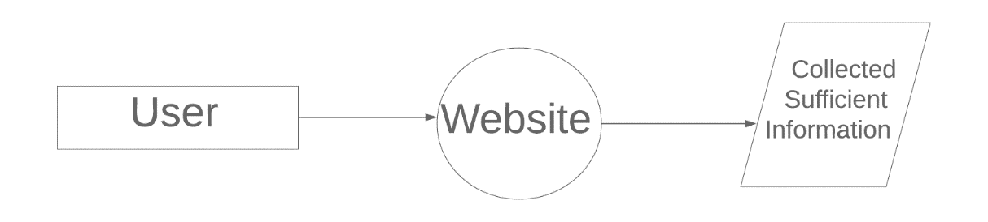
Fig No. 3.1 DFD LEVEL-0

CHAPTER 4
Implementation and User Interface

4.1 Web Page Details
- Home Page
- About Us
- Top 6 Restaurant present in Mathura
- Write a Review
- People Reviewed

4.2 Detailed Description of Pages
1. Home Page The home screen consists of screen where one can browse through the page for getting information about the usefulness of the web page
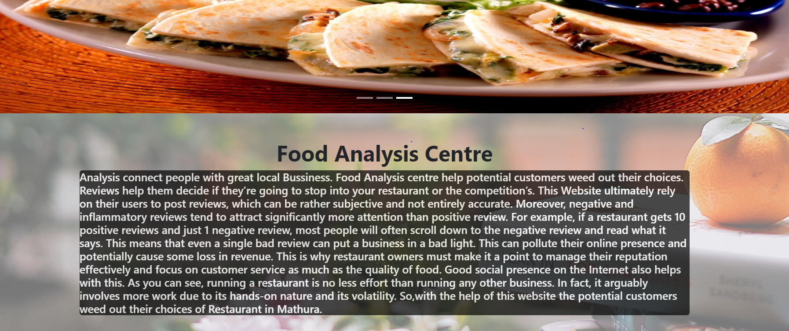
Fig No. 4.1 Home Page

- Top 6 Restaurant Page: The screen consists of screen where one can browse through the top 6 best Rated Restaurant present in Mathura.
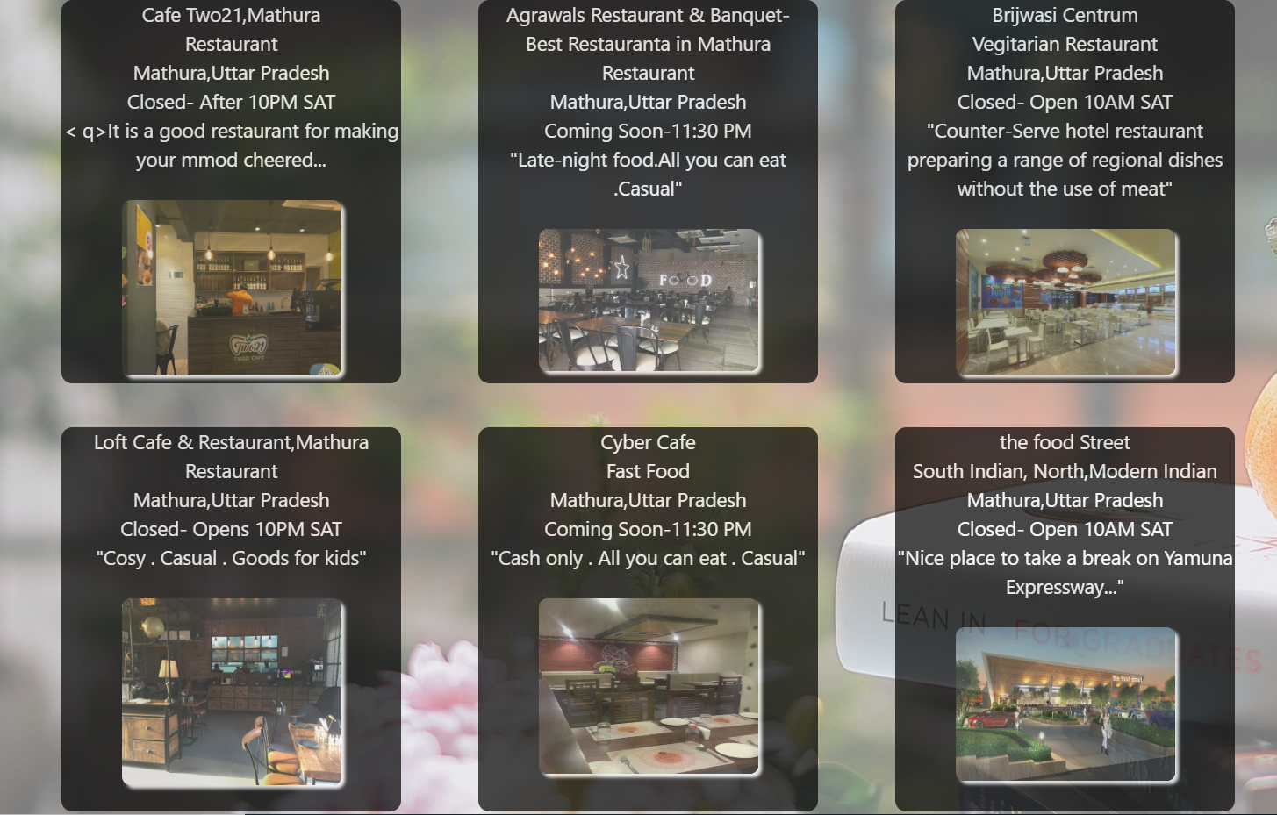
Fig No. 4.3 2. Top 6 Restaurant Page

- Write Your Review: User can also Write a Review of any stuff for any Restaurant Present in Mathura, Because public opinion matters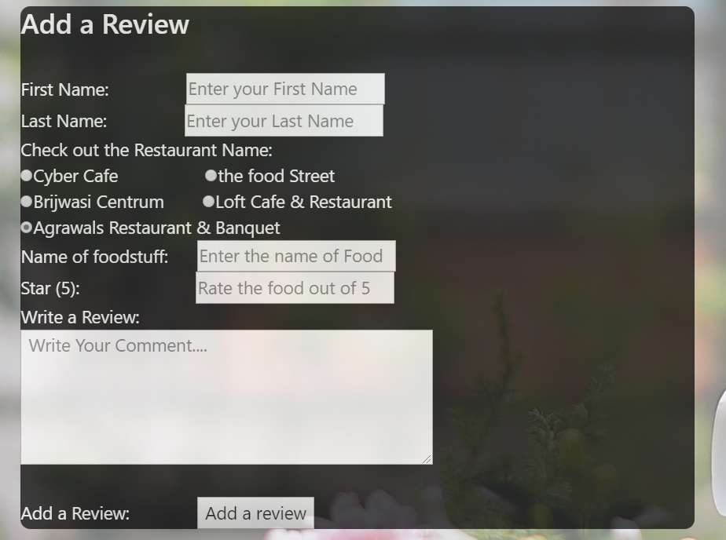
Fig 4.3 Products Page
- Review of the Day: – Here on the Screen some Review Added by the user will be shown.
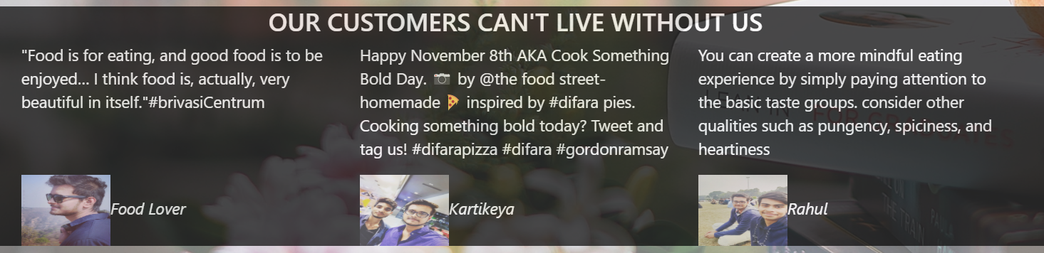
Fig 4.5 Review of the Day Page

CHAPTER 5

Conclusion and Future Aspects

5.1 Conclusion
We have successfully implemented the website “Restaurant Reel” . With the help of various links and tools, we have been able to provide a site which will be live soon and running on the web. We have been successful in our attempt to take care of the needs of both the user as well as the administration. Finally we hope that this will go a long way in popularizing.
5.2 Future Aspects
- We can add query box
- We can add the review of newly opened Restaurant
- We can add sms tool so that the information about the Restaurant can be provided using SMS.
CHAPTER 6
Bibliography

- https://www.w3schools.com/html/default.asp
- https://www.w3schools.com/css/default.asp
- https://www.w3schools.com/bootstrap4/default.asp
- https://mdbootstrap.com/docs/jquery/javascript/carousel/

CHAPTER 7

Appendices

7.1 CSS
- /* CSS for the BackGround Image*/
- .back{
- background-image: url(../Image/bg_hd%20wallpaper.jpg);
- width: 100%;
- height: 100%;
- position: fixed;
- top: 0;
- opacity: 0.6;
- }

- /* CSS for the Description About the web Page*/
- .description{
- background-color: black;
- border-radius: 5px;
- opacity: 0.7;
- color: white;
- }

- /* CSS for the top 6 Restaurant*/
- .customdiv
- {
- margin: 20px;
- background-color: black;
- text-align: center;
- min-height:350px;
- font-size: 18px;
- overflow: hidden;
- border-radius: 10px;
- opacity: 0.7;
- }
- /* CSS for Styling the Information Present in the top 6 Restaurant*/

- .info{
- color: white;
- }

- /* CSS for Styling the Review Centre*/

- .review
- {
- margin: 2px;
- min-height:350px;
- font-size: 18px;
- overflow: hidden;
- }

- .customdiv2{
- margin: 20px;
- background-color: black;
- color: white;
- max-height:950px;
- font-size: 18px;
- overflow: hidden;
- border-radius: 10px;
- opacity: 0.7;
- }
7.2 HEAD
- <!DOCTYPE html>
- <html lang="">
- <head>
- <meta charset="utf-8">
- <meta name="viewport" content="width=device-width, initial-scale=1.0">
- <title>Food Analysis Centre</title>
- <link rel="stylesheet" href="https://stackpath.bootstrapcdn.com/bootstrap/4.3.1/css/bootstrap.min.css" integrity="sha384-ggOyR0iXCbMQv3Xipma34MD+dH/1fQ784/j6cY/iJTQUOhcWr7x9JvoRxT2MZw1T" crossorigin="anonymous">
- <script src="https://code.jquery.com/jquery-3.2.1.slim.min.js" integrity="sha384-KJ3o2DKtIkvYIK3UENzmM7KCkRr/rE9/Qpg6aAZGJwFDMVNA/GpGFF93hXpG5KkN" crossorigin="anonymous"></script>
- <script src="https://cdnjs.cloudflare.com/ajax/libs/popper.js/1.12.9/umd/popper.min.js" integrity="sha384-ApNbgh9B+Y1QKtv3Rn7W3mgPxhU9K/ScQsAP7hUibX39j7fakFPskvXusvfa0b4Q" crossorigin="anonymous"></script>
- <script src="https://maxcdn.bootstrapcdn.com/bootstrap/4.0.0/js/bootstrap.min.js" integrity="sha384-JZR6Spejh4U02d8jOt6vLEHfe/JQGiRRSQQxSfFWpi1MquVdAyjUar5+76PVCmYl" crossorigin="anonymous"></script>
7.3 Navigation Bar

- <!-- Code for Navigation Bar-->
- <nav class="navbar navbar-expand-lg navbar-light bg-info navbar-dark">
- <a class="navbar-brand" href="#">About Us</a>
- <button class="navbar-toggler" type="button" data-toggle="collapse" data-target="#navbarSupportedContent" aria-controls="navbarSupportedContent" aria-expanded="false" aria-label="Toggle navigation">
- <span class="navbar-toggler-icon"></span>
- </button>

- <div class="collapse navbar-collapse" id="navbarSupportedContent">
- <ul class="navbar-nav mr-auto">
- <li class="nav-item active">
- <a class="nav-link" href="#">Home <span class="sr-only">(current)</span></a>
- </li>
- <li class="nav-item">
- <a class="nav-link" href="#">Write A Review</a>
- </li>
- <li class="nav-item dropdown">
- <a class="nav-link dropdown-toggle" href="#" id="navbarDropdown" role="button" data-toggle="dropdown" aria-haspopup="true" aria-expanded="false">
- Rewards
- </a>
- <div class="dropdown-menu" aria-labelledby="navbarDropdown">
- <a class="dropdown-item" href="#">Top 6 Restaurant</a>
- <a class="dropdown-item" href="#">Coupons</a>
- <div class="dropdown-divider"></div>
- <a class="dropdown-item" href="#">Religious Food</a>
- </div>
- </li>
- </ul>
- <form class="form-inline my-2 my-lg-0">
- <input class="form-control mr-sm-2" type="search" placeholder="Search" aria-label="Search">
- <button class="btn btn-outline-success my-2 my-sm-0" type="submit">Search</button>
- </form>
- </div>
- </nav>

7.4 Carousel Card
- <!-- Body Section for Image Carousel -->

- <div id="carouselExampleIndicators" class="carousel slide" data-ride="carousel">
- <ol class="carousel-indicators">
- <li data-target="#carouselExampleIndicators" data-slide-to="0" class="active"></li>
- <li data-target="#carouselExampleIndicators" data-slide-to="1"></li>
- <li data-target="#carouselExampleIndicators" data-slide-to="2"></li>
- </ol>
- <div class="carousel-inner">
- <div class="carousel-item active">
- <img class="d-block w-100" src="../Image/costa.jpg" height="450" width="80%" alt="First slide">
- </div>
- <div class="carousel-item">
- <img class="d-block w-100" src="../Image/food3.jpg" height="450" width="80%" alt="Second slide">
- </div>
- <div class="carousel-item">
- <img class="d-block w-100" src="../Image/food5.jpg" height="450" width="80%" alt="Third slide">
- </div>
- </div>
- <a class="carousel-control-prev" href="#carouselExampleIndicators" role="button" data-slide="prev">
- <span class="carousel-control-prev-icon" aria-hidden="true"></span>
- <span class="sr-only">Previous</span>
- </a>
- <a class="carousel-control-next" href="#carouselExampleIndicators" role="button" data-slide="next">
- <span class="carousel-control-next-icon" aria-hidden="true"></span>
- <span class="sr-only">Next</span>
- </a>
- </div>
7.5 Description About the Page
- <div class="container">
- <div class="row">
- <div class="col-md-12">
- <div class="description">
- <h5><p>
- Analysis connect people with great local Bussiness. Food Analysis centre help potential customers weed out their choices. Reviews help them decide if they’re going to stop into your restaurant or the competition’s.
- This Website ultimately rely on their users to post reviews, which can be rather subjective and not entirely accurate. Moreover, negative and inflammatory reviews tend to attract significantly more attention than positive review. For example, if a restaurant gets 10 positive reviews and just 1 negative review, most people will often scroll down to the negative review and read what it says. This means that even a single bad review can put a business in a bad light. This can pollute their online presence and potentially cause some loss in revenue.
- This is why restaurant owners must make it a point to manage their reputation effectively and focus on customer service as much as the quality of food. Good social presence on the Internet also helps with this. As you can see, running a restaurant is no less effort than running any other business. In fact, it arguably involves more work due to its hands-on nature and its volatility.
- So,with the help of this website the potential customers weed out their choices of Restaurant in Mathura.
- </p>
- </h5>

- </div>
- </div>
- </div>
- <!-- End of div tag for container class(description )-->
- </div>

7.6 Top 6 Restaurant present in Mathura
- <div class="container" >
- <div class="row">

- <div class="col-md-4">
- <div class="customdiv">
- <div class="info"><p>Cafe Two21,Mathura <br>Restaurant<br>Mathura,Uttar Pradesh<br>Closed- After 10PM SAT<br>
- < q>It is a good restaurant for making your mmod cheered...</q><br></p></div>
- <div class="img">
- <img src="https://media-cdn.tripadvisor.com/media/photo-s/13/6d/67/99/two21-cafe-speedmart.jpg" height="160" width="200" style="border-radius:8px;margin-top: 8px;box-shadow: 3px 3px 3px white " alt="">
- </div>
- </div>
- </div>

- <div class="col-md-4">
- <div class="customdiv">
- <div class="info">
- <p>Agrawals Restaurant & Banquet-<br>Best Restauranta in Mathura<br>Restaurant<br>Mathura,Uttar Pradesh<br>Coming Soon-11:30 PM<br><q>Late-night food.All you can eat .Casual</q><br></p></div>
- <div class="img">
- <img src="https://content3.jdmagicbox.com/comp/mathura/j4/9999px565.x565.160322114948.g9j4/catalogue/agrawal-restaurant-mathura-bypass-mathura-restaurants-3s2ca.jpg" height="130" width="200" style="border-radius:8px;margin-top: 8px;box-shadow: 3px 3px 3px white " alt="">
- </div>
- </div>
- </div>

- <div class="col-md-4">
- <div class="customdiv">
- <div class="info">
- <p>Brijwasi Centrum<br>Vegitarian Restaurant<br>Mathura,Uttar Pradesh<br>Closed- Open 10AM SAT<br>
- <q>Counter-Serve hotel restaurant preparing a range of regional dishes without the use of meat</q><br></p>
- </div>
- <div class="img">
- <img src="https://q-cf.bstatic.com/images/hotel/max1024x768/106/106538346.jpg" width="200" style="border-radius:8px;margin-top: 8px;box-shadow: 3px 3px 3px white " alt="">
- </div>
- </div>
- </div>
- <!-- End of the div tag of the 1st Row of the top three Restaurant-->
- </div>

- <!-- Starting of 2nd Row-->
- <div class="row">

- <div class="col-md-4">
- <div class="customdiv">
- <div class="info">
- <p>Loft Cafe & Restaurant,Mathura <br>Restaurant<br>Mathura,Uttar Pradesh<br>Closed- Opens 10PM SAT<br>
- <q>Cosy . Casual . Goods for kids</q><br></p>
- </div>
- <div class="img">
- <img src="https://content3.jdmagicbox.com/comp/mathura/k4/9999px565.x565.181017163829.d1k4/catalogue/loft-cafe-mathura-0jnn2fwuu7.jpg" height="170" width="200" style="border-radius:8px;margin-top: 8px;box-shadow: 3px 3px 3px white " alt="">
- </div>
- </div>
- </div>

- <div class="col-md-4">
- <div class="customdiv">
- <div class="info">
- <p>Cyber Cafe<br>Fast Food <br>Mathura,Uttar Pradesh<br>Coming Soon-11:30 PM<br><q>Cash only . All you can eat . Casual</q> <br></p>
- </div>
- <div class="img">
- <img src="https://media-cdn.tripadvisor.com/media/photo-s/12/f1/40/27/4-6-seater-tables.jpg" height="160" width="200" style="border-radius:8px;margin-top: 8px;box-shadow: 3px 3px 3px white " alt="">
- </div>
- </div>
- </div>

- <div class="col-md-4">
- <div class="customdiv">
- <div class="info">
- <p>the food Street<br>South Indian, North,Modern Indian<br>Mathura,Uttar Pradesh<br>Closed- Open 10AM SAT<br>
- <q>Nice place to take a break on Yamuna Expressway...</q><br></p>
- </div>
- <div class="img">
- <img src="https://i2.wp.com/viriddesignworks.com/wp-content/uploads/2018/04/cam03_View01.jpg?fit=1200%2C675" width="200" height="140" style="border-radius:8px;margin-top: 8px;box-shadow: 3px 3px 3px white " alt="">
- </div>
- </div>
- </div>
- <!-- End of the Div tag for the next 3 Top Ratted Reastaurant-->
- </div>

7.7. Review Matters
- <!-- review centre -->
- ;!-- The Following code is for the review corner,where user can review the food of the Restaurant-->
- <div class="row">

- <!-- FEEDBACK MATTERS-->
- <div class="col-md-8">

- <div class="review">
- <img ssrc="../Image/feedback-matters.png"s alt=""><br>
- <div class="Form">
- <div class="customdiv2">

- <h3>Add a Review</h3><br>
- First Name:

- <input type="text" name="firstname" placeholder="Enter your First Name"><br>
- Last Name:
- <input type="text" name="last name" placeholder="Enter your Last Name"><br>
- Check out the Restaurant Name:<br>
- <input type="radio" name="restaura" value="Cyber Cafe">Cyber Cafe
- <input type="radio" name="restaura" value="the food Street">the food Street<br>
- <input type="radio" name="restaura" value="Brijwasi Centrum" checked>Brijwasi Centrum
- <input type="radio" name="restaura" value="Loft Cafe & Restaurant" checked>Loft Cafe & Restaurant<br>
- <input type="radio" name="restaura" value="Agrawals Restaurant & Banquet" checked>Agrawals Restaurant & Banquet<br>
- Name of foodstuff:
- <input type="text" name="FoodStuff Name" placeholder="Enter the name of Food"><br>
- Star (5):
- <input type="text" name="FoodStuff Rating" placeholder="Rate the food out of 5"><br>
- Write a Review:<br>
- <textarea name="review" cols="50" rows="5" placeholder=" Write Your Comment....">
7.8 Review of the day
- <!-- REVIEW OF THE DAY-->

- <div class="col-md-4">
- <div class="customdiv2">

- <div class="row">
- <div class="col-md-12">
- <img src="../Image/salad.png" alt="" height="100%" width="100%">
- </div>
- </div>

- <div class="row">
- <div class="col-md-12">
- <img src="../Image/cury.png" alt="" height="100%" width="100%">
- </div>
- </div>

- <div class="row">
- <div class="col-md-12">
- <img src="../Image/chop.png" alt="" height="100%" width="100%">
- </div>
- </div>

- </div>
- </div>
- </div>
- </div>

- <!-- The Following Code Shows some People review(testimonial)-->
- <div class="customdiv2">
- <h3 class="text-center">OUR CUSTOMERS CAN'T LIVE WITHOUT US</h3>
- <div class="container">
- <div class="row">
- <div class="col-md-4">

- <p><q>Food is for eating, and good food is to be enjoyed… I think food is, actually, very beautiful in itself.</q>#brivasiCentrum</p><br><br>
- <cite><img src="../Image/kartik1.jpg" width="100" height="80">Food Lover</cite>

- </div>

- <div class="col-md-4">

- <p>Happy November 8th AKA Cook Something Bold Day. 📷 by @the food street- homemade 🍕 inspired by #difara pies. Cooking something bold today? Tweet and tag us! #difarapizza #difara #gordonramsay</q></p>

- <cite><img src="../Image/kartik2.jpg" width="100" height="80">Kartikeya</cite>
- </div>

- <div class="col-md-4">

- <p>You can create a more mindful eating experience by simply paying attention to the basic taste groups. consider other qualities such as pungency, spiciness, and heartiness</p>

- <cite><img src="../Image/Kartik3.jpg" width="100" height="80">Rahul</cite>
- </div>
- </div>
- </div>

